Of Deer and a Cat

The deer love to visit.
When we first arrived on the land our old cat Hana made friends with the deer.
She passed on Hallowsmas when the sacred fire went out.
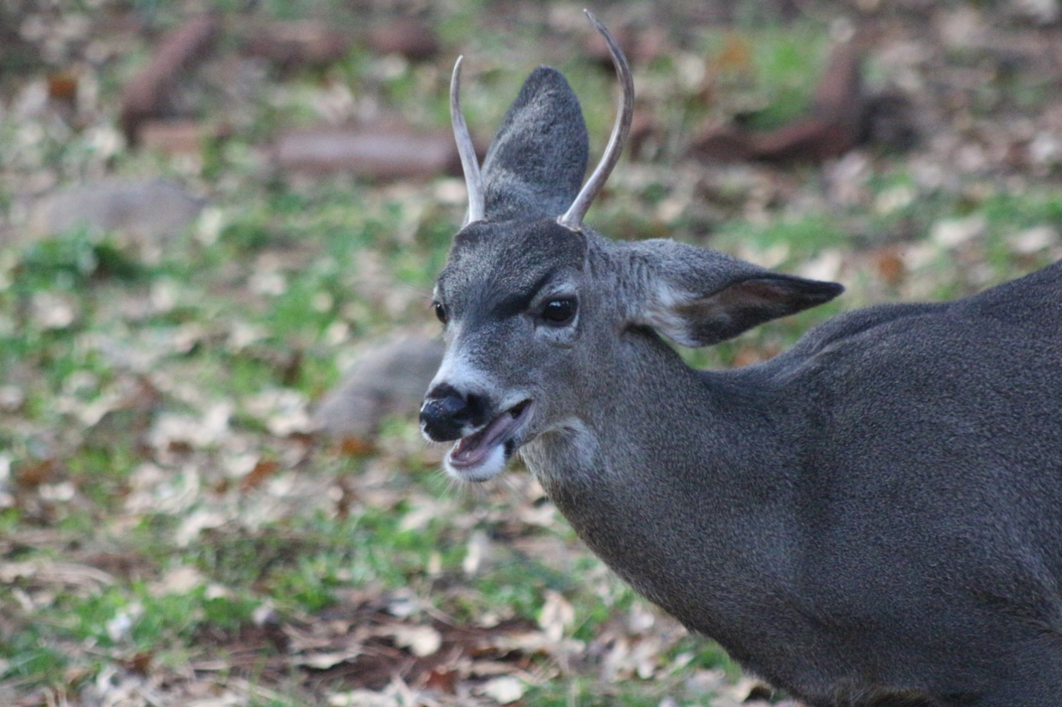
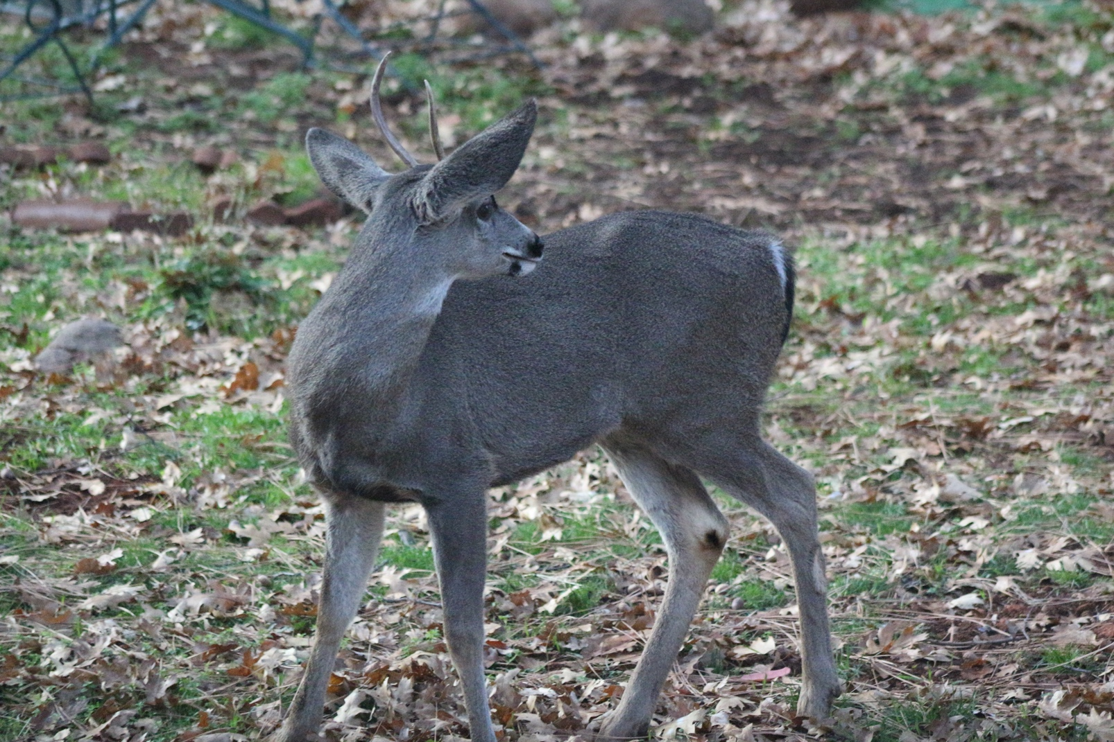
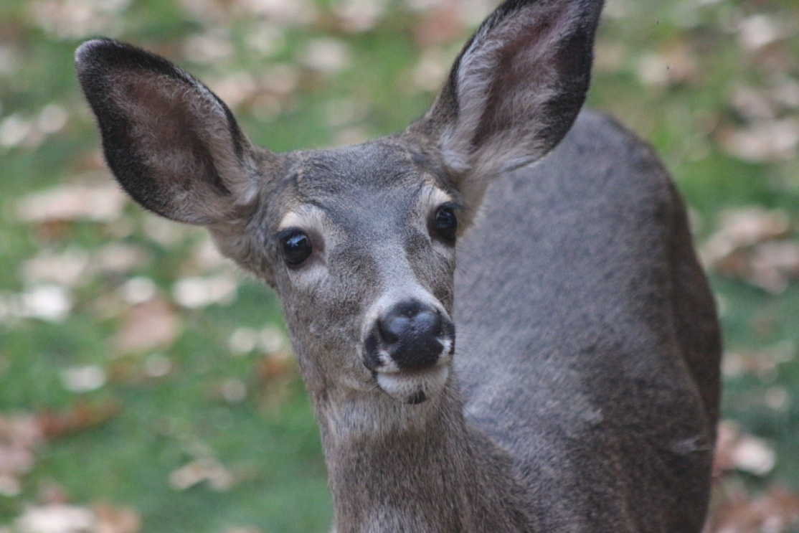
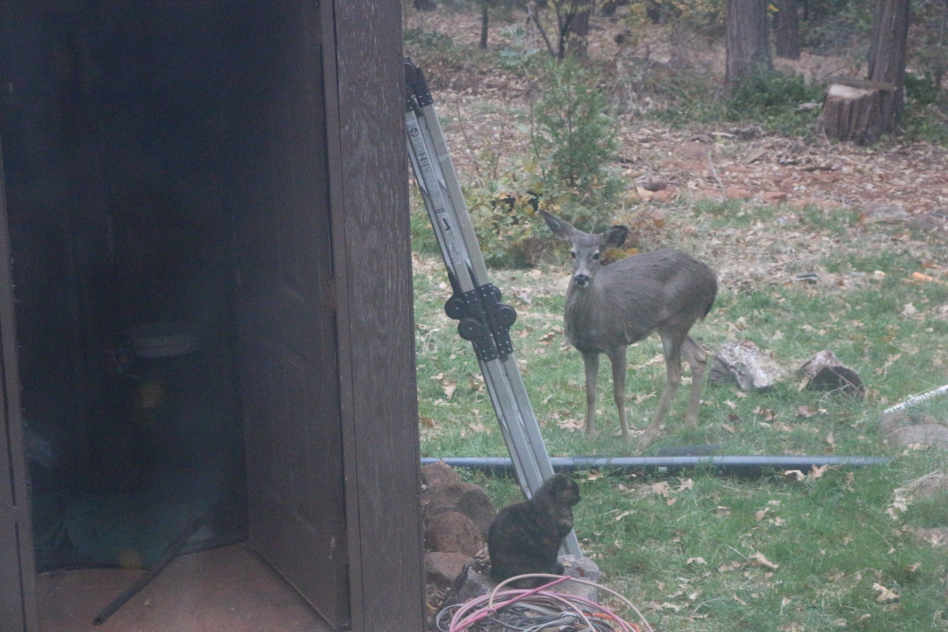
I always think of her when the deer come to visit.

